STUDENTS CENTRIC LEARNING

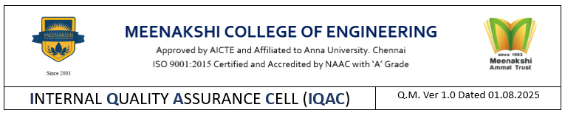
Form AC –SCL01

DEPARTMENT OF NAME OF THE DEPARTMENT
Ref.: MCE/DEPT. NAME/AY/SEM/SCL/RPT Date:

Academic Year |  | Semester

REPORT ON STUDENTS INVOLVED IN STUDENT-CENTRIC LEARNING

Class | Total No. of students | Experiential learning |  |  | Participative learning |  |  | Problem solving
Class | Total No. of students | In-plant Training  # | Industrial Visit  # | Project / Mini Project  # | VAC# | Symposium/ Conference  # | Workshop/ Seminar/ Events  # | Tutorial  # | Coding Contest/ Hackathon  # | Online Certification  #
I Year
II Year
III Year
IV Year
V Year *

* - Applicable only for B. Arch.

HoD IQAC Principal
Form AC –SCL02

DEPARTMENT OF NAME OF THE DEPARTMENT

Ref.: MCE/DEPT. NAME/AY/SEM/SCL/CONS Date:

Academic Year |  | Semester

STUDENTS INVOLVED IN STUDENT CENTRIC LEARNING - % - CONSOLIDATION

Class | Total No. of students | Participative learning |  | Participative learning |  | Participative learning
Class | Total No. of students | Students involved | % | Students involved | % | Students involved | %
I Year
II Year
III Year
IV Year
V Year *

* - Applicable for B. Arch.

HoD IQAC Principal

