NPTEL/ONLINE COURSES COMPLETED DETAILS

Form AC–CC01

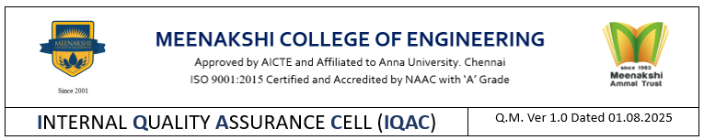
Ref.: MCE/Dept. Name/AY/SEM/CC-F

DEPARTMENT OF NAME OF THE DEPARTMENT

Academic Year & Semester |  | Date

NPTEL / SWAYAM/ OTHER ONLINE COURSES COMPLETED BY THE FACULTY

S. No. | Name of the Faculty | Designation | Name of the Course | Duration  (4/8/12 Weeks) | Marks obtained (in %) | Grade obtained | No. of NPTEL courses completed so far | No. of credits obtained so far

Programme Coordinator HoD
Form AC– CC02

Ref.: MCE/Dept. Name/AY/SEM/CC-S

DEPARTMENT OF NAME OF THE DEPARTMENT

Academic Year & Semester |  | Date

NPTEL / SWAYAM /OTHER ONLINE COURSES COMPLETED BY STUDENTS

S. No. | Year of Study | Class & Section | Register Number | Name of the Student | Name of the Course | Grade | No. of NPTEL/online courses completed so far | No. of credits obtained so far

HoD Principal

