FACULTY ENRICHMENT ACTIVITIES - DOCUMENTS

Ref.: MCE/Dept. Name/AY/SEM/FEA/PL-P Date
Form AC– FEA01

From
Name of the Faculty,
Department of Name of the Department,
Meenakshi College of Engineering,
Chennai- 600078.

To
The Principal,
Meenakshi College of Engineering,
Chennai- 600078.
Respected Sir/Madam,
Subject: Request for permission to attend Program Name
I hope this message finds you well. I am writing to seek your kind permission to attend the Program Name, which is scheduled to be held on Date(s) at Venue/Organizer Name. The program focuses on briefly mention the theme or objective of the program, e.g., recent developments in teaching methods, research collaboration, curriculum development, etc., which I believe will significantly contribute to my professional development and teaching/research capabilities.
Attending this program will not only enhance my knowledge but also provide valuable insights that can be shared with our department for academic benefit. I assure you that I will manage my academic responsibilities accordingly and ensure minimal disruption to my regular duties.
So, I kindly request you to grant me a permission with on duty and a registration fee of Rs ………. to attend the same. I am also happy to provide a summary report or presentation on key takeaways upon my return. Thank you for considering my request. I look forward to your kind approval.
Yours sincerely,

Signature of the faculty
Encl.: Program Enrolment form (if available)
Signature of the Head of the Department | Signature of the Administrative Officer | Signature of the Principal | Executive Director

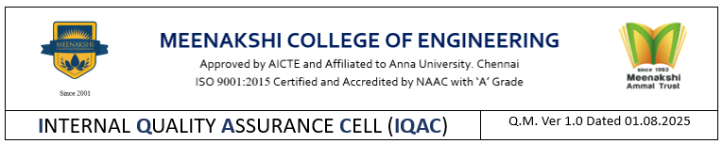
Form AC– FEA02

Ref.: MCE/Dept. Name/AY/SEM/FEA/EPR Date

DEPARTMENT OF NAME OF THE DEPARTMENT
EVENT PARTICIPATION REPORT
Name of the Faculty :
Designation :
Name of the Event :
Host Institute/ Organization :
Date(s) :

Description about the event participated details (by covering nature of the event, objectives, geo-tagged necessary photos with description) in 500 words. Attach the certificate provided by the event host Institute.

Outcomes:
List out 2-3 outcomes of the event (for Seminar/Workshop/Conference)

Signature of the Faculty HoD Principal

Form AC– FEA03

Ref.: MCE/Dept. Name/AY/SEM/FEA/CR Date

DEPARTMENT OF NAME OF THE DEPARTMENT
Programme :
Academic Year :
FACULTY ENRICHMENT ACTIVITIES CONSOLIDATION REPORT
S. No. | Name of the Faculty | Designation | Event Title | Host Institute | Date(s) | Financial assistance received (from College) in Rs. | Certificate details  (Provide google drive open link) | Event report submission status
 |  |  |  |  |  |  |  | Details updated in Dept. webpage | Uploaded in ERP

HoD Principal
Form AC– FEA04

Ref.: MCE/Dept. Name/AY/SEM/FEA/FID Date

FACULTY ENRICHMENT ACTIVITIES_FEE REIMBURSEMENT DETAILS
S.No. | Reference ID | Name of the Faculty | Department | Designation | Category | Title | Host Institute/ Organization | Date/Duration of the Program | Amount reimbursed in Rs. | Document submission status
 |  |  |  |  |  |  |  |  |  | Establishment Section | Finance Officer

IQAC Principal
Copy to:
- Executive Director

